**NEW JERSEY INSTITUTE OF TECHNOLOGY**

**SENIOR CAPSTONE PROJECT**

**SPRING 2025**

**Title Page: Final Report**

**Title: LPWAN for Smart Agriculture**

**Sponsor: NONE**

**Team Members: Pavan Patel, Judrianne Mahigne, Michael Cantarero, Xavier Ruiz**

**Course Name:**

**Section: IT491**

**Instructor Name: Dr. Eljabiri**

* **Chapter 1: Introduction - Pavan**
  + **Project Background**
  + **Problem Definition**
  + **Glossary of terms used**
* **Chapter 2: PROJECT MANAGEMENT -** 
  + **Task Analysis, Roles**
  + **WBS/Gantt,**
  + **Risk Identification and Management**
* **Chapter 3: DEFINE**
  + **Stakeholders, Requirements Gathering, Project Scope**
  + **FDD Requirement grouping and Use Case Diagrams**
* **Chapter 4: DESIGN**
  + **ER, Class, Network Diagrams, Implementation Details**
  + **Survey of at least three (3) alternative solutions and a comparison between them**
* **Chapter 5: DEVELOPMENT - Jude**
  + **Outputs / Screenshots and description of your Solution.**
  + **Develop a brief User Manual for the intended user of your solution**
* **Chapter 6: EVALUATION AND CONCLUSION -(Collectively) - Write name down next to your conclusion**
  + **Solution Testing, Verification, Validation. Team conclusions: What did you learn, what would you do differently, were you successful?**

**Chapter 1: Introduction**

**Project Background**

Agriculture is a very important part of the global economy and food. but still it is very vulnerable to natural disasters like wildfires, floods, and wildlife incursions. Natural disasters have the potential to inflict massive economic damages, annihilate crops and livestock, and destroy rural livelihoods. Current disaster detection schemes are usually manual or employ very expensive technology not affordable in far-flung and resource-constrained agricultural fields. In addition, many conventional methods of wireless communication don't have the range to extend to large farming fields or are far too power-hungry to support prolonged, outdoor urban implementations.

For purposes of addressing such challenges, the proposed project aims to utilize the implementation of a Low Power Wide Area Network (LPWAN) system for smart agriculture. Incorporating Internet of Things (IoT) sensor networks into LPWAN communication protocols, the system offers low power consumption and wide-area coverage disaster detection in real time. In particular, the proposed project simulates network infrastructure for detecting environmental disasters like wildfires, floods, and wildlife movement, and delivering early warnings to farmers to facilitate early preventive measures.

The system uses sensors such as temperature, humidity, soil moisture, and motion sensors to detect environment conditions. Information from the sensors is relayed through a simulated LPWAN network to a server, where the processing is done and real-time messages are generated. Simulation was done using Cisco Packet Tracer, with modifications to simulate the behavior and limitations seen in any LPWAN network owing to software constraints. Long term, the solution is low-cost, scalable, and sustainable to protect farming operations from disaster threats.

**Problem Definition**

Modern agriculture is increasingly calling for access to real-time environmental data to achieve maximum productivity, save resources, and safeguard assets. Most rural and inaccessible farms, however, have no adequate communications infrastructure. Conventional wireless solutions like Wi-Fi or cellular networks are impractical due to high power requirements, inadequate coverage, and recurring fees.Farmers need to have an efficient and cost-effective solution offering:

* Continuous monitoring of the environment,
* Early alert and warning of approaching danger
* Operation over long distances with fewer battery changes.

The goal of the project is to achieve all these specifications by modeling a low-cost, energy-efficient LPWAN disaster detection system. Cost-effectiveness, dependability, and scalability are the focuses of the system design to deploy in the field in real scenarios.

**Glossary**

**LPWAN (Low Power Wide Area Network):**A wireless communication technology intended for low-bit-rate long-distance communication, which is well-suited for the needs of IoT in big outdoor environments.

**IoT (Internet of Things):**An integrated network of computing technology incorporated in everyday items, which facilitates the collection and transmission of data.

**Gateway:**A device for linking sensor networks to broader data processing networks or to the internet, facilitating communication and data aggregation.

**Wildfire Detection Sensors:**Environmental sensors that monitor dryness, heat, and smoke in order to sense any possible danger of wildfires.

**LoRaWAN (Long Range Wide Area Network):**A popular LPWAN protocol that enables communication at long distances using low-power devices without cellular networks.

**Cisco Packet Tracer:**A simulation tool for network design and simulating network topologies and behaviors, utilized by the project to simulate conditions like that of LPWAN.

**Iteration or Revision Updates**Iteration or Revision Work Several changes were made during the course of the project to adapt to technical and logistical issues: Simulation Approach: Initially, the project aimed at simulating communication using LoRaWAN. Due to the fact that Packet Tracer does not natively support simulating LoRa, the team improvised by simulating an equivalent low-power low-data-rate wireless environment using readily available sensor nodes. Optimization of network design: Revisions of original designs were made to optimize network segmentation and routing via an emulated backplane to improve data delivery and reliability to multiple farm zones. Sensor Optimization: The sensor configuration was further developed according to midterm reviews to simulate real disaster conditions better, including soil moisture for floods and infra-red for wildlife detection. Security Controls: As part of addressing the initial risk appraisal, standard network security controls were included in the simulation to safeguard data under transmission from eavesdropping. These iterations made the eventual design a much stronger, more realistic, and resilient LPWAN disaster detection mechanism for intelligent agriculture.

**Chapter 2: Project Management**

**Task Analysis**

To ensure the completion of LPWAN for Smart Agriculture project, there was a structured task decomposition from the beginning. The project tasks were divided into deliverable and technical milestone-based logical phases:

1. **Project Planning and Research:**
   * Researching LPWAN technologies and limitations.
   * Exploring disaster detection systems for IoT.
   * Deciding on system objectives and success metrics.
2. **Network Topology Design:**
   * Designing a simulated LPWAN network in Cisco Packet Tracer.
   * Designing sensor node placement on simulated fields.
3. **IoT Sensor Configuration:**
   * Selecting and configuring appropriate environmental sensors, e.g., fire detector, lawn sprinklers.
4. **LPWAN Integration:**
   * Integrating sensor data transmission with a simplified LPWAN-like setup in Cisco Packet Tracer.
   * Simulating gateway and server communications.
5. **Cloud Integration and Data Processing.**
   * Designing simulated server data aggregation and alerting mechanisms.
6. **Security Implementation and Testing:**
   * Implementing basic network security measures.
   * Reliability and vulnerability testing of communications.
7. **Performance Analysis, Final Documentation, and Presentation:**
   * System performance analysis.
   * Final report preparation and caption presentation.

Such assignment of work kept focus on every individual milestone without sacrificing project wholeness and completion within a time period.

**Roles**

Every team member was assigned a particular role based on his/her area of expertise and strength:

* **Pavan Patel - Project Manager:**
  + Handled project planning, task assignment, and overall progress.
  + Coordinated meetings and carried out decision-making tasks.
* **Judrianne Mahigne - IoT Developer:**
  + Handled IoT device configuration and deployment in the simulation.
  + Researched and installed disaster detection sensor configuration.
* **Michael Cantarero - Systems Administrator:**
  + Performed server installation for data receiving.
  + Configured communication channels and data processing channels.
* **Xavier Ruiz - Network Designer:**
  + Implemented network topology to stimulate LPWAN behavior.
  + Solved communication issues such as low power and limited range.

By proper role clarification, the team was able to distribute workload appropriately and become specialized in different areas of the system.

**Work Breakdown Structure (WBS) and Gantt Chart**

A Work Breakdown Structure (WBS) was also created to delineate the primary tasks and subtasks that were needed in order to successfully deliver the project. Each of the tasks had corresponding deadlines throughout the 12-week period of the project.

| **Major Tasks** | **Subtasks** | **Timeline** |
| --- | --- | --- |
| Planning & Research | Technology research, scope definition | Weeks 1–2 |
| Design | Network topology, node planning | Weeks 3–4 |
| Development | IoT sensor configuration, LPWAN integration | Weeks 5–8 |
| Testing | System security and performance testing | Weeks 9–10 |
| Finalization | Report writing, presentation preparation | Weeks 11–12 |

The following Gantt Chart detailed the project timeline and displayed it graphically:

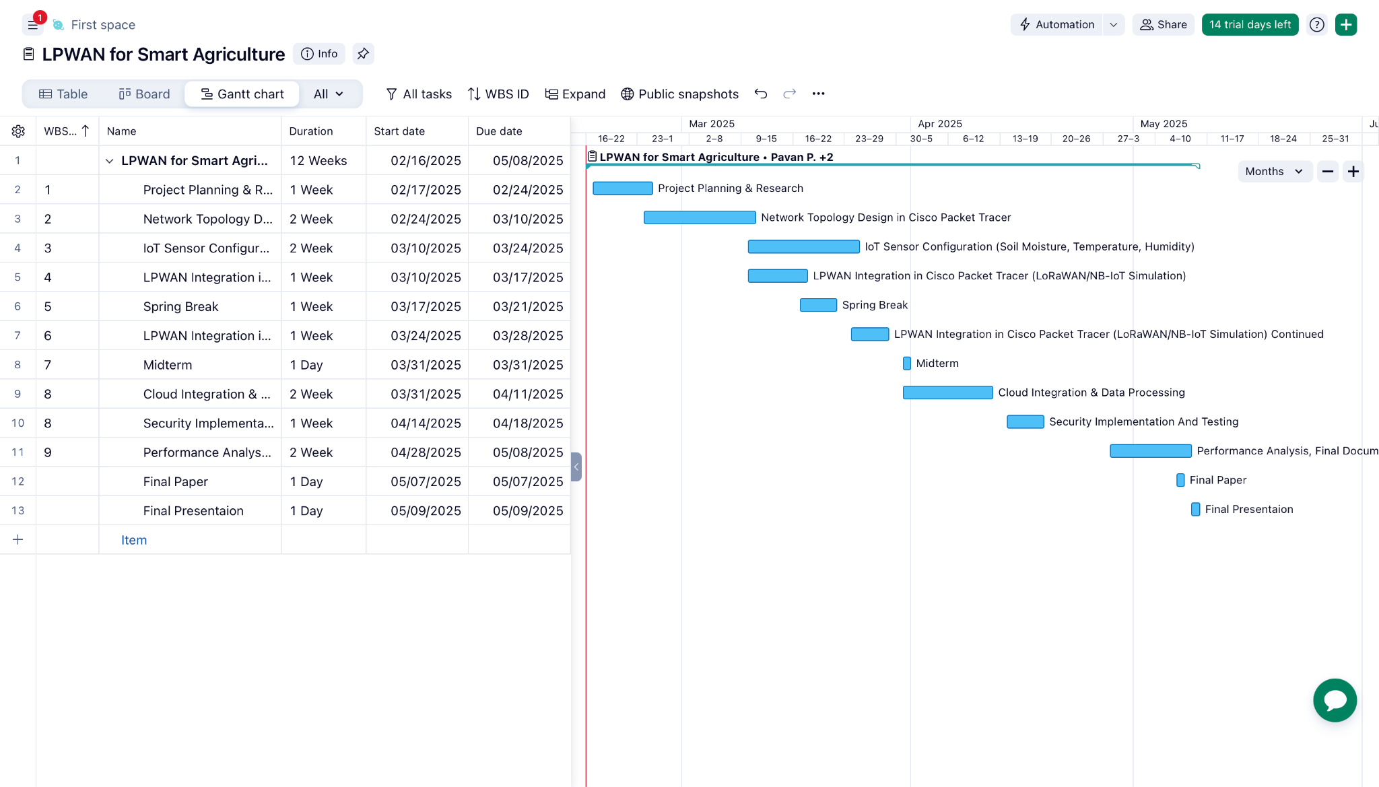

The timeline enabled the team to track the milestones, recognize any delays earlier, and stay organized throughout the project.

**Risk Identification and Management**

One of the primary risks that were identified during the planning of the LPWAN for Smart Agriculture project was the production of false alarms. As a highly sensor-dependent system, its ability to detect peril in the surroundings depends on correct information from the sensors. False data resulting from sensor faults, environmental noise, or calibration fault could lead to sending the wrong kind of alerts to farmers. These false alarms would cause unwarranted panic, reduced system trust, and may prevent warnings from being taken seriously when genuine threats exist. To counteract this risk, the team utilized conservative sensor calibration during the simulation period and employed threshold-based alerting methods to not catch anomalous or short-term changes that can induce false positives.

The other major threat was network limitations, particularly in terms of delivering continuous communication between remotely deployed sensors and the gateway. LPWAN solutions are designed for long-distance communication, but characteristics of the terrain, construction of buildings, and meteorological conditions may influence signal strength and data quality considerably. When sensor nodes fail to deliver data reliably, the critical alerts will be lost or delayed, which undermines the entire purpose of the system. In an effort to negate this, the project team simulated optimal sensor deployment strategies through numerous gateways as required for redundancy and reducing gaps in transmission.Packet transmission timing was also set to conserve power without sacrificing timely updates such that even distant sensors could communicate optimally over lengthy distances.

**Chapter 3: DEFINE**

**Stakeholders**

We define stakeholders as 3 separate categories; **Primary Stakeholders** which are People/Entities that are directly involved and/or affected by the project. **Secondary Stakeholders** are People/Entities that are indirectly affected due to the completion of this project. **Tertiary Stakeholders** are People/Entities that are affected subsequently to the completion of this project.

**Primary Stakeholders**

1. **The Customers (Farmers)**

* First and foremost the client is going to be using the product deployed around the farm. They are also trusting within us the ability to secure the network, maximize uptime and range of the network, and keep it modular incase any installations need to be added elsewhere on the farm. This has a direct impact on the crops due to the automated irrigation system, and as well as a cattle of potential wiring systems to keep them in an enclosed environment. Having the system function is of utmost importance since the farmers will heavily rely on this new system for maximum efficiency.

1. **The Company (Providing Service)**

* The providers are putting their reputation and future revenue at risk each time they provide this service for a new customer. Reviews in this type of business matters, because you need to have durable equipment, and good software for uptime. As well as if something goes wrong with the equipment, how you respond to the client and fix the problem effectively determines the future clients positive outlook on your business and are more inclined to acquire it.

**Secondary Stakeholders**

1. **Local Farms**

* The initial client's purchase of the LPWAN system will affect how nearby farms operate. This is due to the fact that any clients will have the ability to leave the area and still have a monitor on their produce/cattle. This allows them to make necessary purchases or even advertising outside their normal reach. If something is occurring they can go back and minimize damage since the data will be displayed and notified in real time. So if local farmers don’t adapt to the stronger competition they will fall behind unless they can find a way to keep ahead of the curve without migrating to this new system. Minimizing problems occurring across the land makes more crops survive until they are ready to harvest and minimize losses in the herd.

1. **ISPs**

* The network provider is providing necessary connection to the edge router. The following IP addresses on that network will be private on necessary devices, but the LPWAN devices won’t need to have access to the network but the IoT controller will need a connection. For external network uses, having internet availability is just as important as the internal system itself.

**Tertiary Stakeholders**

1. **Consumers**

* With the clients obtaining this new service it will allow consumers to see a wider variety of produce appearing at the market or better quality at the supermarket. This system mitigates loss to total yields allowing greater amounts of crops to be sold and distributed.

**Requirements Gathering**

1. **Role Assignment**

* Upon creation of the group, roles were assigned to designate specific tasks each group member would perform.

1. **Determining Work Process**

* Detail a week by week structured step for completing the LPWAN architecture.

1. **Scheduled Meetings/Trainings**

* For ensuring proper work completion every week the Project Manager would inform of necessary training chapters to complete for the following week's addition to the LPWAN networking simulation.

**Project Scope**

The scope of this project is to Simulate an LPWAN network that can communicate with the farmer whenever he wishes to know the status of the network, or send a notification whenever something abnormal is occurring on the system such as a fire, drought, or over saturation. The simulated network will be on two plots of land but is eligible to be expanded upon thus making it modular. Each plot will consist of a subnetwork that then leads to an IoT controller that the LPWAN devices are connected to. There is also a home network that has an IoT server within it as a master server to view every single IoT device.

**FDD**



**Chapter 4: Design**

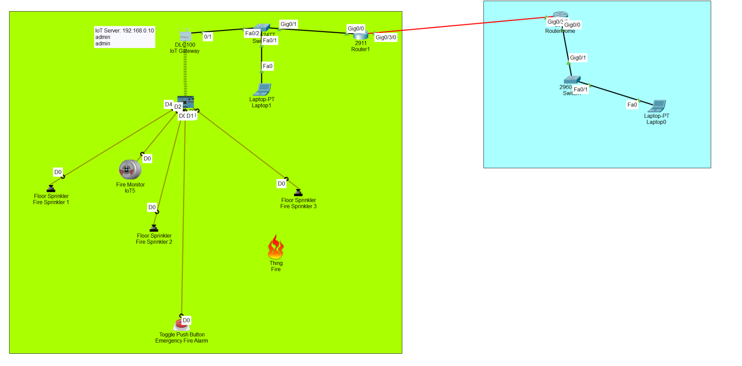

Our topology went through a few updates over the course of the semester, however, the most relevant versions are V1, the midterm draft, and V1.6, the final product. V1 (pictured above) is the midterm draft where we narrowed down the design philosophy we had for our project. V1 consisted of a WAN with two LANs bridging across from each other. The green is one of the farm plots where we set up our first IoT devices. The first system of IoT devices were meant to simulate an irrigation system in the event a fire broke out. The sprinklers were directly connected to an SBC controller, where we coded them to turn on if one of two conditions were met:

* The fire alarm was tripped
* The emergency button was pressed

The reasoning behind the first conditional is self-explanatory, however, we believed that there should be a failsafe in order to manually turn on the sprinklers in case of a fire. The SBC controller was connected to an IoT Gateway, which was then routed onto a switch that connected to the greater network. In this version of the network, the Gateway acted as the server for the IoT devices. It had limited capabilities in what it could do, as it had no features to allow for account creation to limit the people who could view the devices. The rest of the network was dedicated to simulating the devices that the ‘workers’ and ‘owner’ would use to access the IoT database. The laptop in the farm plot and the laptop in the blue area (farmhouse) are used by workers and the owner respectively to access the IoT devices. The network was a proof of concept that demonstrated that our design philosophy could access IoT devices on the network remotely and monitor them for activation. We identified that the network required a few adjustments in the form of security and scalability. This revelation also dictated our design plans for a hybrid network which would support more end users and IoT devices for the network to support.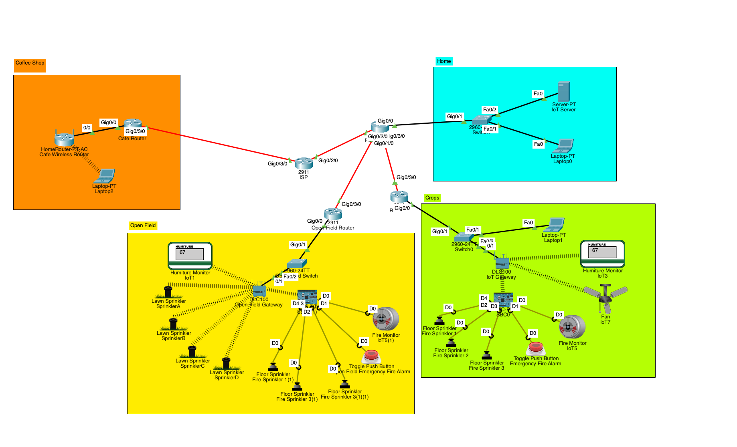 This leads us to the last iteration of our topology that our team came up with (pictured above). Our team followed along with the hybrid topology design so as to not lock ourselves to any particular style. The IoT networks followed a star topology design that had all devices connected to a gateway that was routed to the rest of the network. We fleshed out the amount of devices and added important infrastructure such as an IoT server. Our team also added a secondary location away from the farm entirely that could demonstrate accessing the IoT service without being at home.

*Chapter 4-B: Topology Comparisons*

Our network followed a standard that was achievable in packet tracer, however, there exists different topologies that could be implemented with real-world technologies that aren’t available in PT.

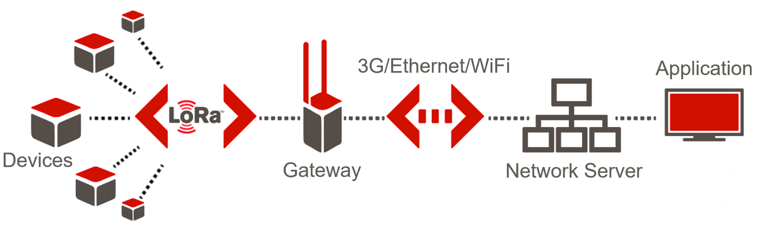The LoRaWAN topology (pictured above) demonstrates a LPWAN that connects the IoT devices to external servers via LoRa radiowaves. The difference betweren LoRaWAN and what we used is the transmission method. Our connections to the IoT devices were established using copper-straight-through cables that connected the gateway to a router that sent the communications out to the greater internet. Speaking objectively, the LoRaWAN communication would use less power since it would ride the radiowaves to transmit information, however, our solution fits the restrictions imposed by packet tracer since the software does not support LoRaWAN and it still provides a relatively low power communication method by limiting the devices need to communicate with a central server. The LoRaWAN diagram does also state that Ethernet and WiFi can be used to communicate to the server; our team used both in the separate farm plots to connect the IoT devices to the server.

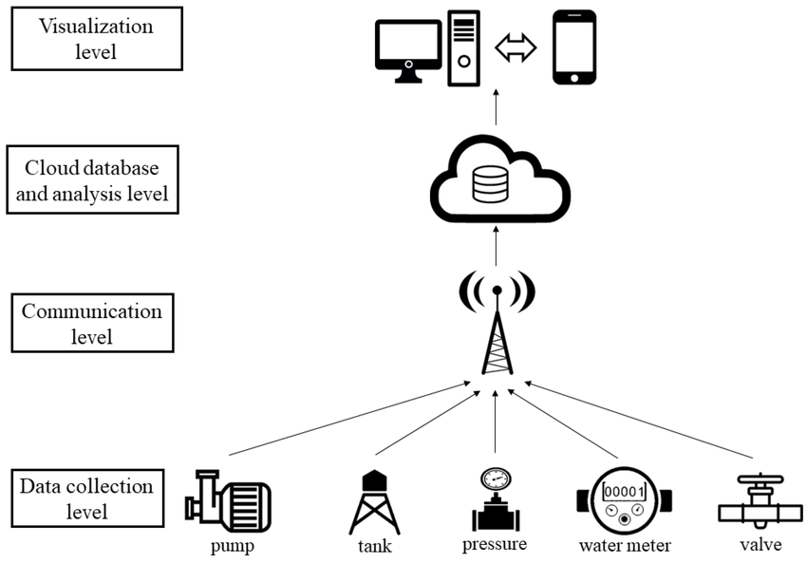

The next basic topology (pictured above) invisions the implementation of the cloud within the LPWAN network. The topology simplifies the design by breaking it into three layers where a cloud system is used to host the IoT service. In packet tracer, there is cloud architecture built into the software. The downside is that it would force the server to be hosted behind the cloud, such as in the example screenshot (pictured right). It’s possible in packet tracer, however, we believed that it would be best for our solution to host the server in the farmer’s home. This was a creative decision as the location of where the server is hosted doesn’t change our solution, it just changes the amount of hops needed to communicate with it.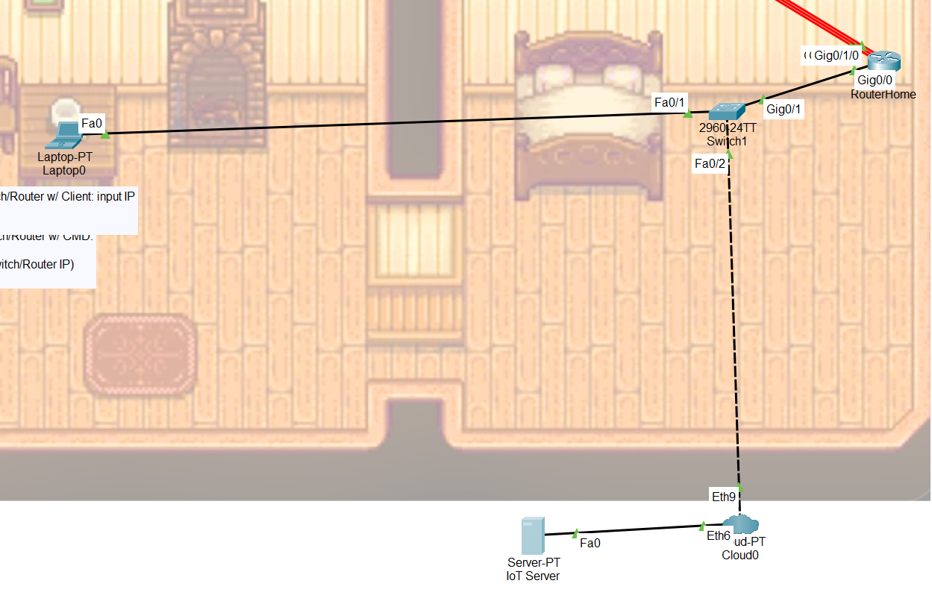

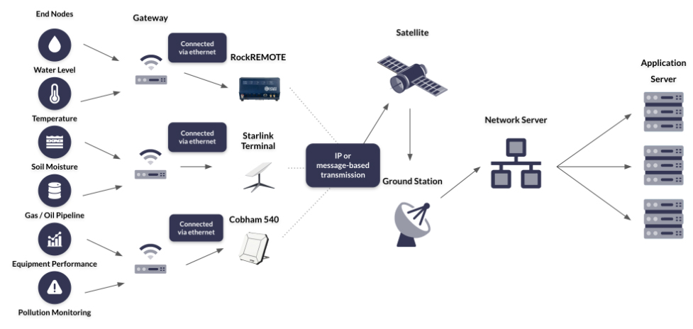The last example topology that could’ve been used in a LPWAN network is a satellite based one (pictured above). This topology invisions data from the IoT devices being transmitted to satellite relays in order to route data back to the IoT server. Comparing this topology with our own, besides the RockREMOTE, which supposedly used radio communications, all of the satellite relay switches would most likely have comparable power usage if enough data is being sent. That being said, packet tracer does not have any options for satellite communications, thus rending this type of topology inaccessible under our restrictions. In a real world scenario, if the IoT devices needed to send data alot further and in bulk, the satellite method is a viable option for LPWAN networks.

**Chapter 5: Development**

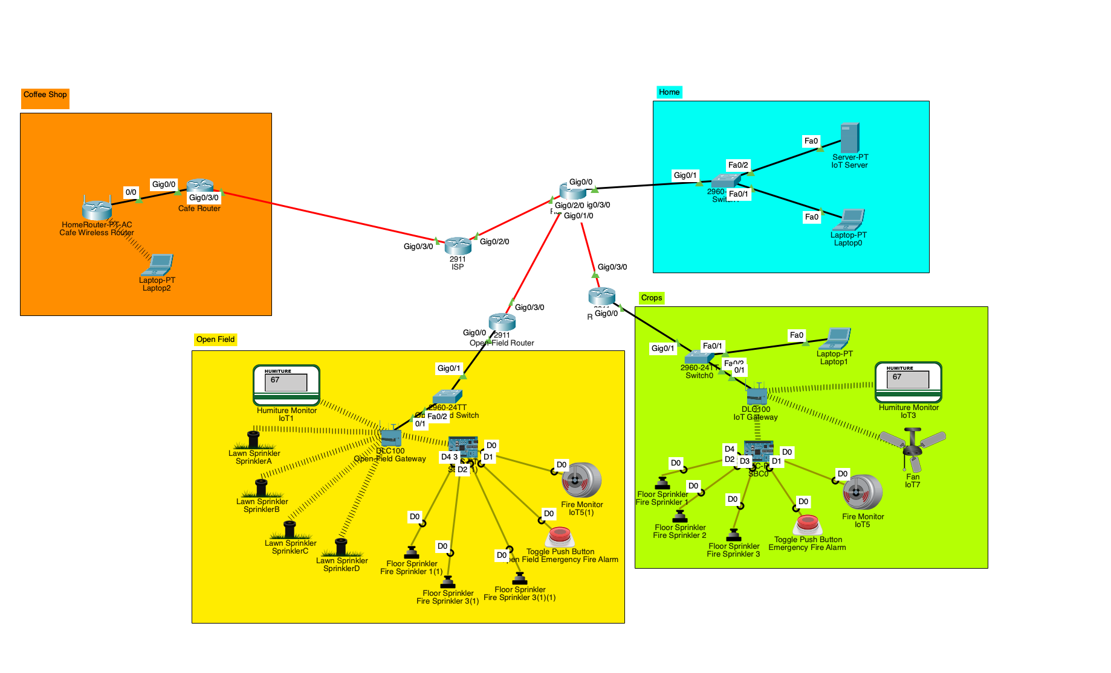

The above image displays a typical network that is usually found in rural or even suburban environments. The yellow, green, and teal coded areas are our farmhouse network that is segmented to represent areas that would be commonly found in an agriculture environment. The yellow area references outdoor crops, while the green area references an indoor greenhouse for our project example. The orange area represents a coffee shop; a network that would be outside the farm LAN network in order to provide a demonstration that one could access and monitor the status of each area of the farm with the IoT devices.

For our specific project, our team implemented LPWAN by creating a custom Single Board Computer (SBC) with a custom python script which is responsible for the fire monitoring and automated fire sprinkler when fire or smoke was detected in the farm. The custom IoT board also featured a manual override unit that models as an emergency fire alarm button for human intervention. Even this is handled by a central IoT server, which logs and monitors in real time for the authorized users of the farmhouse network.

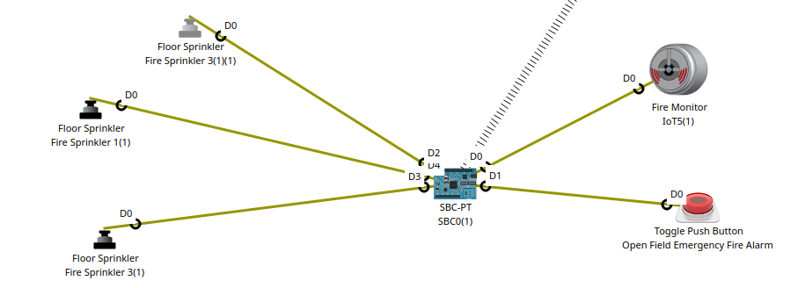

In the following picture, we illustrate how easily the LPWAN device can be made part of the farmhouse network by merely typing in the IPv4 address of the remote IoT server and, if necessary, supplying the relevant authentication credentials. Upon connection, the IoT server immediately starts recording events and sending real-time status from the LPWAN device. This system enables the farmhouse to rapidly send out alarms in the event of a fire and automatically activate any associated fire deterrent systems, such as sprinklers.

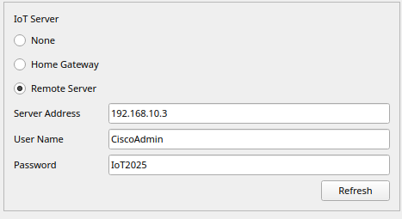

By incorporating this type of networked automation, farms can significantly enhance their safety protocols while reducing response time during emergencies. The simplicity of deployment, combined with the robustness of remote monitoring, highlights the practical benefits of leveraging LPWAN technology in modern agricultural settings.

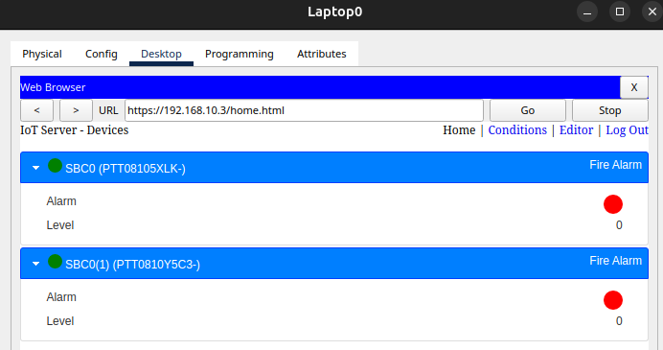

In this example, we will simulate what happens when the LPWAN device detects a fire and the activation of the fire sprinklers in order to quickly extinguish the fire automatically without the need for manual activation. As soon as fire is present within range and at a higher tolerance than normal to account for hot and arid farming environments, the SBC unit sends a signal to each connected fire sprinkler and notifies the system that a fire has occurred. Depending on the alarm system of a farmhouse, this could be a visual alarm such as emergency lights and/or sound via fire alarm. Either way, the system that this LPWAN is connected to will send data back to the IoT server or what IoT managing system with the appropriate notification.

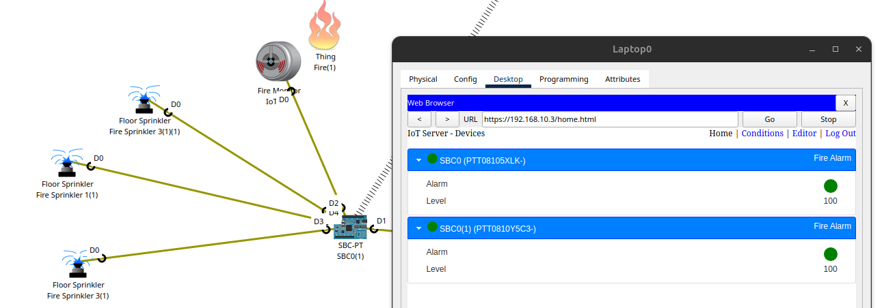

Depending on the alarm infrastructure available at the farmhouse, such a response may feature visual signals in the form of flashing warning lights and/or audible fire alarms. Irrespective of the system utilized, LPWAN ensures that all information pertaining to the incident is relayed back to the central IoT server or IoT management system available. This replaces any proprietary equipment and provides a plug and play solution for any agriculture management systems. This provides the ability for authorized personnel to monitor, confirm, and alert to emergencies in real time, which improves the safety, automation, and reliability of the agricultural facility.

**Chapter 6: Evaluation and Conclusion**

**Solution Testing, Verification, and Validation**

Testing and validation were essential steps to ensure the success of the LPWAN for Smart Agriculture project. Having established the network topology in Cisco Packet Tracer and the IoT sensors, the team performed a number of tests to ensure that the system functioned as expected under different conditions.

First, the team tested the effectiveness of the environmental sensors. All sensor type were correctly configured to give realistic readings of the environment. Controlled scenarios were created by the team to trigger threshold conditions, and they could test if indeed the alerts were effectively triggered by the IoT server.

Second, the communication reliability of the network was tested. Since Cisco Packet Tracer does not support real LPWAN protocols such as LoRaWAN, the team simulated available wireless sensor nodes to mimic long-range, low-bandwidth communication capabilities. Network delays and minimal packet loss were introduced by the team during testing to observe the system's behavior. The simulation continuously sent critical sensor data to the centralized IoT server with data integrity preserved even in resource-constrained network settings.

The team also tested simple network security implementations. Simple encryption techniques and access control policies were implemented to protect sensor data and prevent unauthorized devices from communicating with the server. These verification processes made data transmission secure and only allowed authorized devices to communicate with the system.

With this stringent testing process, the LPWAN for Smart Agriculture simulation was able to successfully demonstrate its ability to monitor environmental conditions, detect hazardous conditions, and provide real-time notifications to farmers.

**Team Conclusion**

**Xavier Ruiz**

This project was an interesting thought of how it can be completed. I usually hear about how people don’t think agriculture and technology could mix. Which would get me thinking how they could mix and this project had given me a good understanding of how smart agriculture exists now. As well as the usefulness it could bring to the customers who would wish to incorporate this technology into their land.

I feel like I could’ve added more to the topology to show a commercial plot point of view instead of a local farm to portray how modular our network can be. However, the initial goal of the project was to design and implement an LPWAN network which was completed. And we even managed to show how it can communicate with the internet.

**Michael Cantarero**

Design-wise, this project was very challenging to set-up. Packet tracer is a powerful software that can simulate many different networks, however, LPWAN seems to push the boundaries of PT to it’s limits. We had to take many liberties when trying to keep the power-consumption of the devices low as many of the low-power communication methods are unavailable in packet tracer.

I believe that our solution was successful in creating an LPWAN with the restrictions imposed by packet tracer. In a real-world situation, there are much better technologies that could be used which would simplify the topology and lower the power-consumption of the network. If packet tracer had a wider-range of transmission options, this solution would not be sufficiently in compliance with the low-power requirement. As it is right now, it would require constant power from a renewable source, such as solar or wind, and would require more than one battery to power the system due to the reliance on edge routers to communicate with the greater network.

**Judrianne Mahigne**

During the development of the custom IoT device, I found how easy it was to integrate different systems together with only a simple Python script. Mind you, the documentation for the MCU or SBC boards are not available online, as I had to reverse engineer the sample IoT packet tracer files provided by Cisco in order to understand the syntax and the needed variables for the system to work. So the script that we have created in our packet tracer could easily be translated to act as a different type of system; not just an automatic fire deterrent system.

Understanding how the LPWAN system operate with an already existing system fundamentally helped me understand how versatile LPWAN can be and how underrated it is when compared to other options such as WiFi and LTE. LPWAN does not require specific infrastructure to operate when using LoRa or LoRaWAN as they can essentially operate as nodes; thus creating a mesh system. It requires less power than traditional mediums as a small 2000mah lipo battery pack can keep a system going for weeks; even longer if renewable resources are used such as solar or wind. Finally, LPWAN reduces cost for small business solutions as each prebuilt device cost less than $100 each.

**Pavan Patel**

Development of the LPWAN for Smart Agriculture project helped me build critical skills in network design, IoT integration, and project management. Through being a project manager, I learned how to schedule, plan tasks, and drive the team to meet deadlines while maintaining technical quality. The project further enhanced my expertise in working with simulation tools like Cisco Packet Tracer and designing low-power, long-range communication networks for real-world applications.

One of the primary things that I learned was to be flexible when there is a plan change. Although we started out to mimic LoRaWAN, technical limitations forced us to adapt our design. What I learned from this experience is the importance of being creative when issues arise.